APPLICATION FORM
Date. 30-08-2026
Application for the Post of LAB INSTRUCTOR in COMPUTER APPLICATION. Department
(Fill in all the details)

Name of the candidate Father . : M HARISH KUMAR
Fathers Name : A MURUGESAN
Mothers name : M LATHA
Date of Birth & Age : 19-04-2002 & 24
Address for Communication : 1/86 MAIN ROAD T MUDIYANUR
THAGADI POST, TIRUKOILUR TALUK, KALLAKURICH DISTRICT
Mobile Number / Landline with STD Code : 7598161757
Aadhar No. : 4148 3723 4552 PAN No. :JRTPM3140J
E-mail ID : harishkumarmurugesan19@gmail.com
Community : OC BC MBC SC/ST Caste: MBC

Educational Qualifications :
Qualification | Name of the Institute | Name of the University | Year of passing | % or CGPA | Class
X Std | sri lakshmi vidhyalaya hr sec shool Arakandanallur | state board | 2018 | 63%
XII Std |  | state board | 2020 | 50%
  sri lakshmi vidhyalaya hr sec shool Arakandanallur
U.G | Karan arts and science Thiruvannamalai | Thiruvalluvar University | 2023 | 73% | 1st class
P.G | MCA | Bharathidhasan University | 2026 | 75% | 1st class
M.Phil / Others | ---------
Ph.D. | ---------
Experience Profile :
Name of the College/Industry | Designation | Joining Date | Relieving Date | Experience | Salary drawn
PWD OFFICE | Computer operator | 15-03-2025 | 15-03-2026 | one year | 10000
TOTAL EXPERIENCE

No. of Papers published in National / International Journals and Conferences:
National / International Journals :
Conferences :
Time required to join : 07-09-2026
Expected salary : 13000 per month

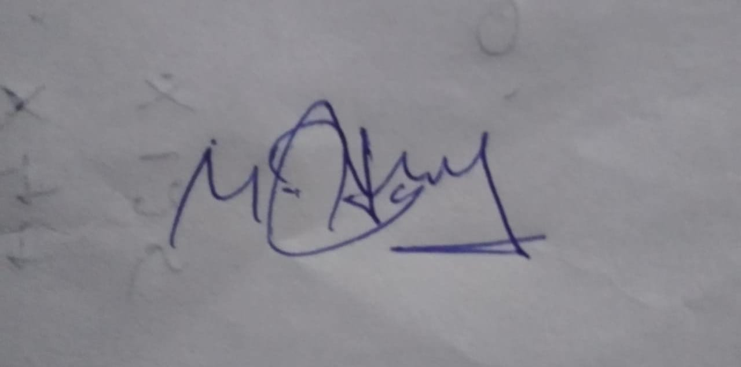

Signature of the Candidate

